Product Description

XTOOL X100 Pro2 Auto Key Programmer is a hand-held device for programming keys in immobilizer units on vehicles. This scan tool has a simple and robust design, to make your vehicle service experience much easier!

**XTOOL X100 Pro2 Auto Key Programmer with EEPROM Adapter**

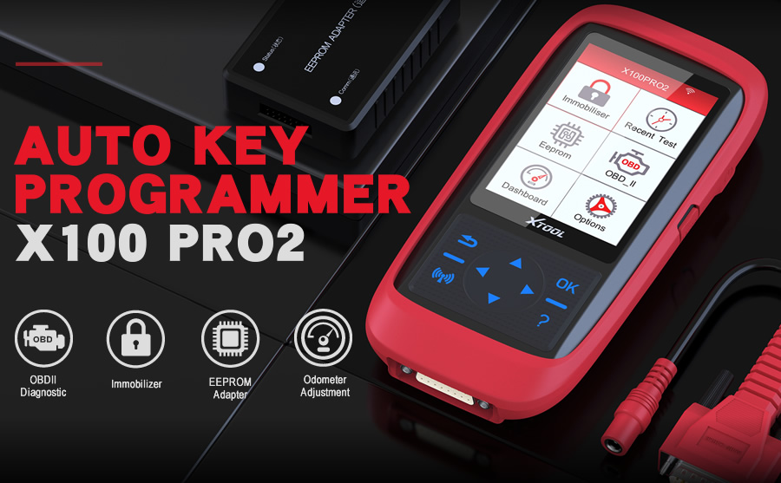

**XTOOL X100 Pro2 Highlights:**  
  
1. Support most European, American, Asian and Chinese Cars on key programming functions  
2. One Key Update via Wifi on Officail Site. Upgradeable via web-based download, Upgrade step, please reference page 11-14 on user manual.   
3. One Year Warranty.  
4. Support Multi-language: English, Spanish, Portuguese, French, German, Russian, Polish, Italian and Chinese  
  
**Notice:**  
1. Xtool X100 Pro is a key programmer, please don't count on too much on the mileage correction functions.  
2. Dealer Code: XT0240  
  
**Description:**  
  
Xtool X-100 Pro2 is updated version of X100+, including X100+ all the matching function and add new software function. This scan tool has a simple and robust design, to make your vehicle service experience much easier!  
Support Reset ECM and reset immobilizer, read keys from immobilizer's memory, vehicle indentification number programming.  
  
**Features:**

1. New keys programming  
2. Read keys from immobilizer memory  
3. New immobilizer programming  
4. New mechanical key number programming  
5. Vehicle Identification Number programming  
6. Reset ECM & Reset Immobilizer  
7. Easy to operate by guiding menu programming  
8. New remote controller programming  
9. With full and strong database for the most important vehicle makes  
10. Upgrade via web-based download

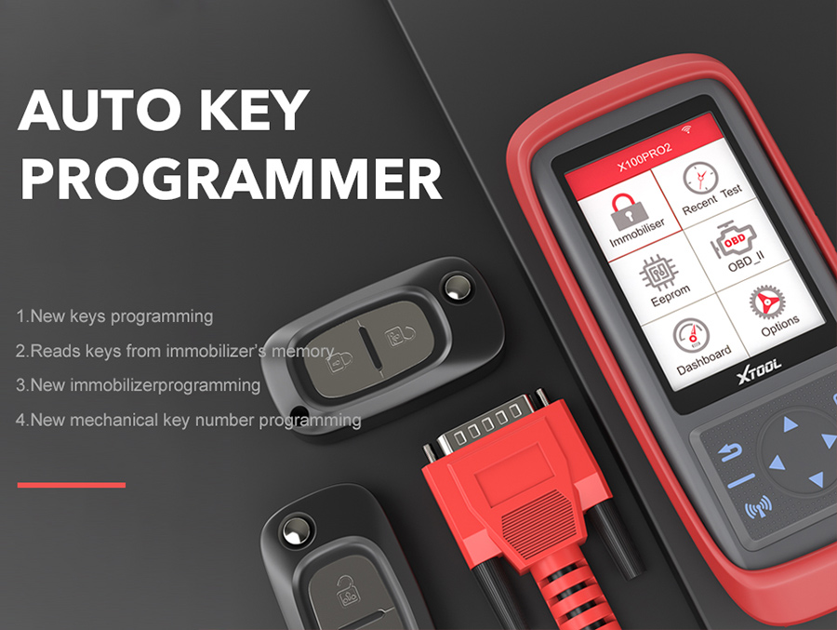  
  
**XTOOL X100 Pro2 Basic Functions:**  
  
1. Immobiliser  
2. OBDII Diagnosis  
3. EEPROM  
4. Odometer Adjusement  
  
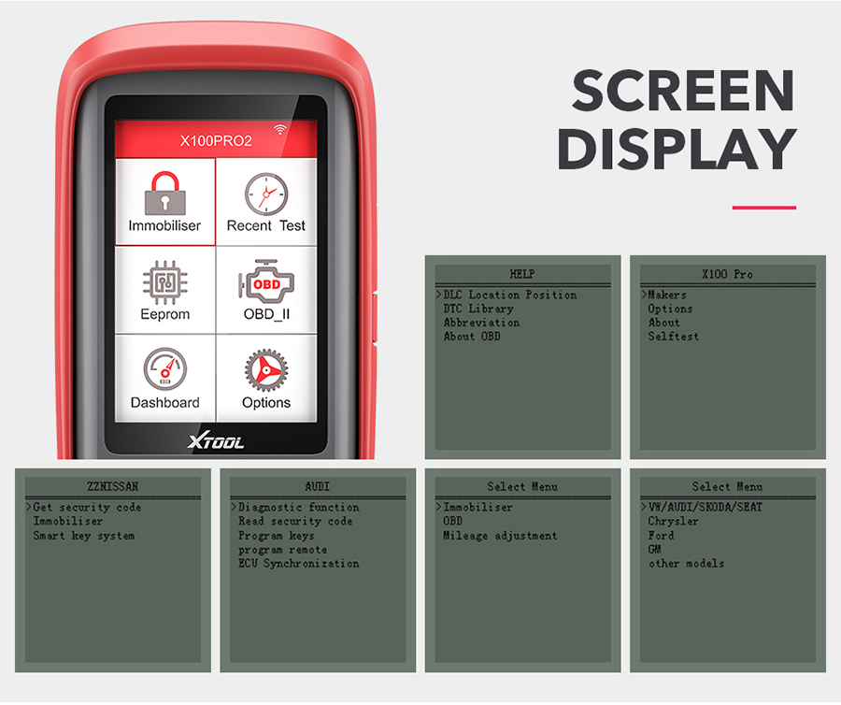  
  
**XTOOL X100 Pro2 Special Functions:**  
  
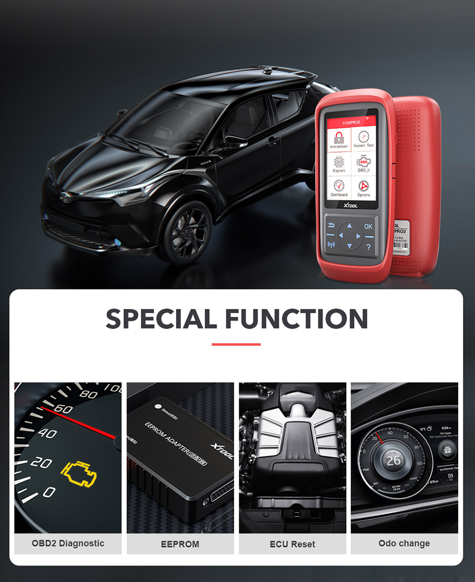  
  
OBD2 Diagnostic: Can read Engineer systems error code via the OBD2  
EEPROM: Works for some old car models not suit the obd2 can work with the eeprom contact with ,also can work for some chips  
ECU Reset: When your ECU get any Error code keeps shows problems  this x100 pro can make Reset for the ECU  
  
**XTOOL X100 Pro2 Vehicle Coverage:**

|  |  |  |
| --- | --- | --- |
| Region | Function | |
| Immobilizer | Odometer Adjustment (Support Partial Models Only) |
| Asia | Toyota; Honda; Acura; Mazda; Lexus; Mazda; Nissan; Infiniti; Mitsubishi; Subaru; Suzuki; KIA; Hyundai; SSANGYONG; QNLUTUS; Mitsuoka | Hyundai; Infiniti; Isuzu; KIA; Mazda; Mitzubishi; Nissan; Proton; SSANGYONG; Subaru; Suzuki |
| Europe | Audi; VW; Skoda; Seat; Porsche; Opel; Citroen; Peugeot; Jaguar; Land Rover; Renault; Benz; Ferrari; Fiat; Maserati; MG; Smart; DS | Audi; Bentley; Benz; Citroen; Ferrari; Fiat; Jaguar; Land Rover; Maserati; Peugeot; Porsche; Renault; Seat; Skoda; Smart; Volvo;VW |
| America | Lincoln; GM; Chrysler; Ford | Buick; Cadillac; Chrysler; Ford/Lincoln; GMC; Hummer; Oldsmobile; Opel; Pontiac; Saturn |
| China | Changan; Changfeng;Changhe; Chery; Brilliance; BYD; Huapu; JAC; Lifan; GreatWall; HNMAZDA; Lufeng; Roewe; SQYL; ZZNISSAN; Luxgen; Geely; Hongqi; Hawtai; Besturn; Baic; Baojun; Dffengshen; Dfliuzhou; Betpurn | Besturn; Geely; Greatwall; MG Roewe |

**How to Update Xtool X100 Pro2?**  
  
1. Go to Xtool Official Website and go inside the X100 PRO2  
  
2. Contact the X100 PRO2 with the Laptop  
  
3. Download the Update helper then click the update for the newest software  
  
Notice: Please close the antivirus software before download, don't create an acount when you get this X100 pr Tool. Please log in directly with SN number and password (in "About" option of setting part) in our device.

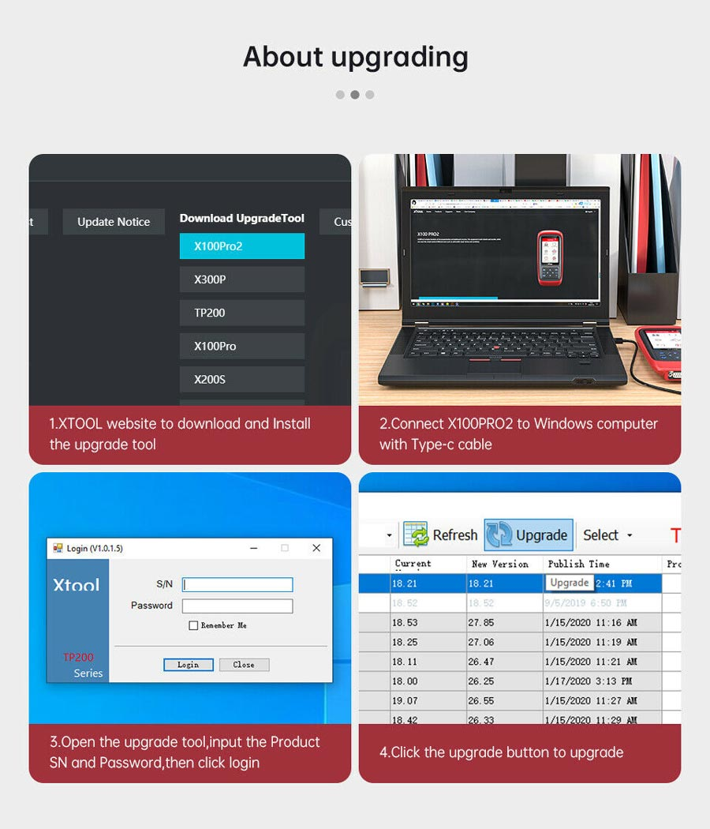  
  
**Solution When XTOOL 100 Pro2 Displays White Screen or No Application:**  
  
Step 1: Connect PRO2 to a Windows PC, find the memory card, and format it.  
Step 2: Log in the upgrade tool and click upgrade  
Notice: During the upgrade, please do not operate the key of the machine or disconnect the data line. After the upgrade prompt is successful, unplug the data cable and reconnect it.  
  
**XTOOL X100 Pro2 FAQs:**  
  
Q1: Will this program key for Mercedes Benz C200  
A1: Can not do key programming for benz.  
  
Q2: I work at a facility that buys auction cars, without keys. Will this start the vehicles without the keys? If not then what product will?  
A2: Nice work. Xtool product does not support that amount vehicles for All key lost. try our [X100 PAD2 Pro](https://www.uobdii.com/wholesale/x-100-pad2-with-vw-4th-5th-immo.html) or [X100 Pad 3](https://www.uobdii.com/wholesale/xtool-x100-pad3.html)  
  
Q3: Will it program keys for 2017 dodge grand caravan and 2005 Dodge Ram 1500  
A3: I can't say but it did programming my keys for 2003 Honda Civic  
  
Q4: It is working for 2008 honda accord?  
A4: Yes it support this car for keys.  
  
Q5: How to get Xtool X100 Pro Back to Normal When You Get White Screen Problem?  
A5:  
Step 1: Connect PRO2 to a Windows PC, find the memory card, and format it.  
Step 2: Log in the upgrade tool and click upgrade  
(Attention！！！During the upgrade, please do not operate the key of the machine or disconnect the data line. After the upgrade prompt is successful, unplug the data cable and reconnect it.)  
  
Q6: Does this work for mileage correction?  
A6: Yes for partial cars.  
Not Support Mileage Correction List according to customers' feedback so far:  
Peugeot Expert 2013  
Ford c max 2012  
Fiat punto evo 2012,   
Jeep renegade 2015,   
VW Golf5, 7 2005/ 2015  
Landrover Discovery 2016  
Range Rover (Evoque) Discovery 4  
Renault Grand Scenic 1.6 diesel 2013  
Toyota Yaris diesel 2007  
Fiat 500l 2014  
  
**XTOOL X100 Pro2 Reviews:**  
  
if you lost keys to your vehicle this is a great tool a lock smith or having the dealer do it will cost you around 500 so by doing it your self with this device you save your self 300$ roughly this device also has a old 2 scanner and on select models you can adjust your miles. overall this is a great product and is very well made.  
  
I'm impressed. Was able to program 3 aftermarket keys to my 2009 Outback XT and it did not ask for the immobilizer or teaching code. I haven't tried updating it yet and was easy to use.  
  
Worked like charm. Programmed an aftermarket key for my 2014 Lexus Rx350 at first try. I see its even capable of doing mileage adjustment. But it did not work on my 2011 Toyota Avalon. It did not even connect. I do not understand how it would work and program 2014 Lexus and not a 2011 Toyota Avalon. Hence the one star drop. For the money? Its a good buy.

**Parameter:**

|  |  |
| --- | --- |
| Monitor | 320x480 DPI TFT Color Display Screen |
| Working Voltage | 9V-18V |
| Working Temperature | -10℃-60℃ |
| Storage Temperature | -20℃-70℃ |
| Appearance Size | (LxWxH) 92*33*200mm) |

**XTool X100 Pro2 Specification:**  
  
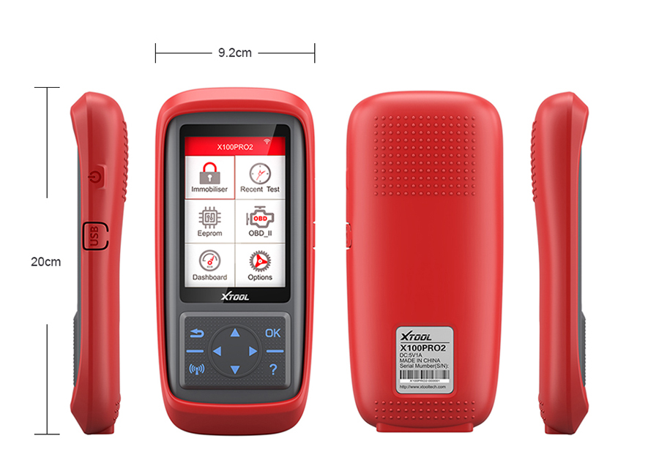  
**XTOOL X100 Pro2 Package List:**  
  
1 pc x XTOOL X100 Pro2 Main Unit  
1 pc x Honda-3  
1 pc x OBDII-16  
1 pc x KIA Hyundai-10  
1 pc x KIA-20  
1 pc x EEPROM  
1 pc x EEPROM Adapter  
1 pc x Power Adapter 12V/1A  
1 pc x Main Cable  
1 pc x Micro USB Cable  
1 pc x US Power Adapter  
1 pc x EU Power Adapter  
1 pc x Plastic Box